**Daily_report_20200407**

**Back-Trader Environment setting**

Now I mainly focus on setting Back-trader environment on my computer. It is lucky that I have printed the Back-Trader guide so that I can know most of their structure. However, I think the main propose of this on-home Back-Trader can just finish basic functions, such as loading data, implement strategies with indicators and generate all the log file. It is hard to implement optimized method because of laptop can’t run so much data.

Now the following are the steps I should rewrite in my computer.

|  |  |  |
| --- | --- | --- |
| ITEMS |  | Condition |
| BackTrader package |  | Finished(from github) |
| HISTDATA READER |  | Finished |
| Analysis | Total_log_analysis | \ |
| Indicators |  | Finished one sample |
| Influx | fetch_df | \ |
| Process_data | \ |
| Observer | Order Observer | \ |
| Strategy |  | Finished one sample |
| untils | Backtesting_setting | \ |
| Strategy_base | Finished |

As soon as I can finish all function above, I can run strategy with manually input and get log results like I do in the office.

**BackTrader package:**

Test success, I have run sample strategy from the website

**HistDATA:**

I download some data In EURUSD in my computer and write a function to read that, I can set start date and end date, it will concat them together

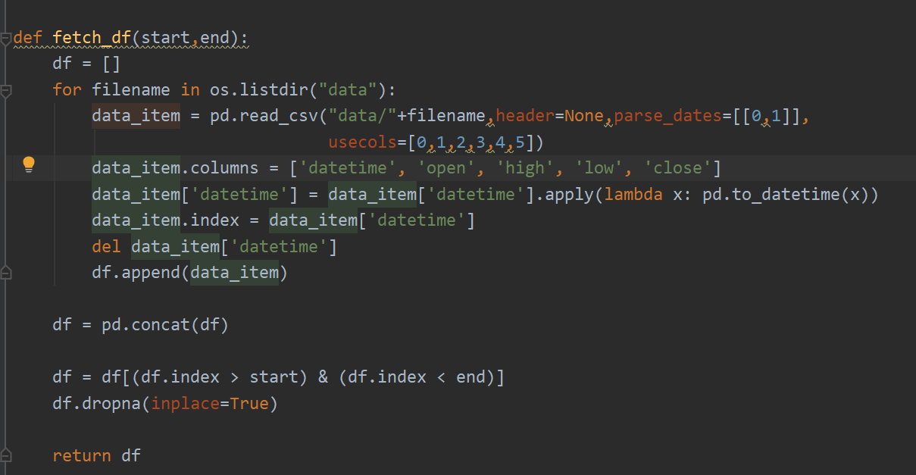

**Indicators:**

Finished one sample, for convenient to add in

**Strategies:**

Finished one sample, for convenient to add in

**Strategy base:**

Mostly Finished:

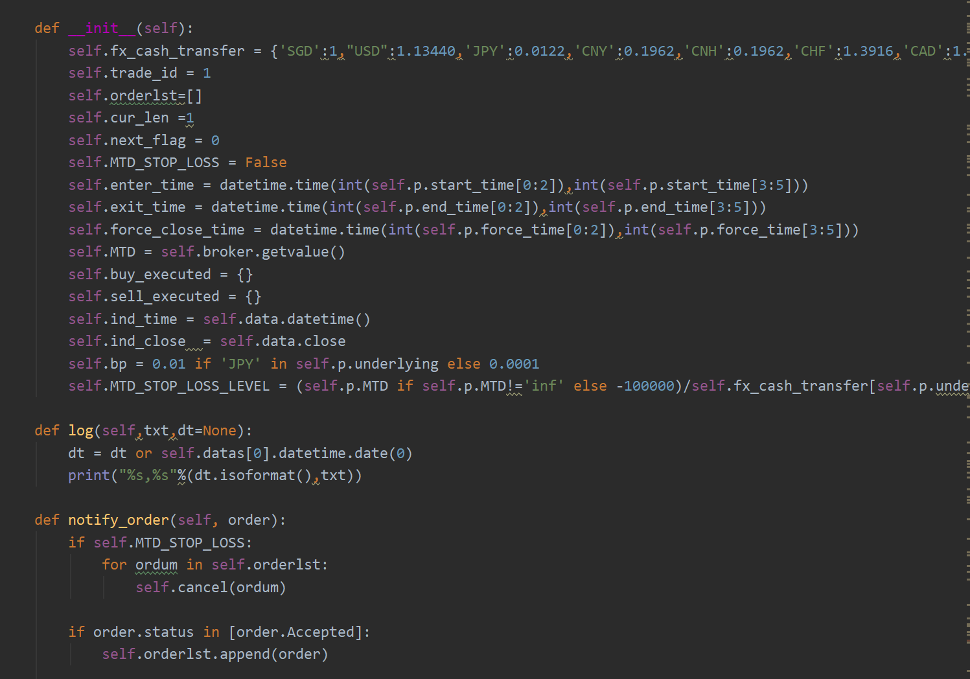

……follow about 200 lines😊

However, this function has not test because now the workflow can’t implement.

I estimate it will cost me serval days to completely set backtrader environment. As for checking for what we have implemented, I want to know more clear about this question, Do you mean what strategies(indicators?), functions(like command input…..) we already have?

7th April 2020

Hao